No

Yes

Yes

Output

7

6

1

3

Input

Sample Input and Output

1<=T<=1000 1<=N<=10000

Constraints

Print "Yes" in the case Alice wins, else print "No"

Output Format

stones.

First line starts with T, which is the number of test cases. Each test case will contain N number of

Input Format

opmally.

one to make the rst move. Your task is to nd out whether Alice can win, if both play the game

player who picks the last stone, wins. They follow the "Ladies First" norm. Hence Alice is always the

be the total number of stones. In each turn, a player can remove either one stone or four stones. The

Q1) Alice and Bob are playing a game called "Stone Game". Stone game is a two-player game. Let N

WEEK 4

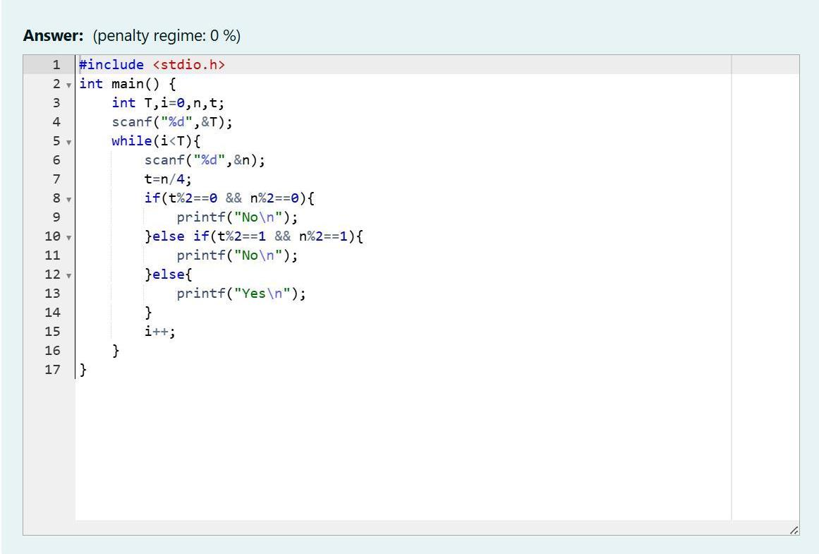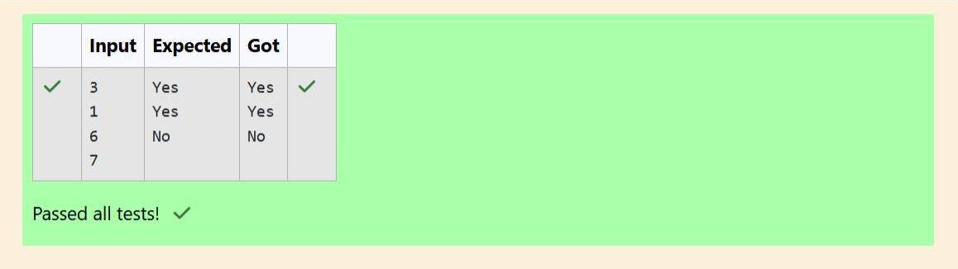

Add the holes count for each digit, 1, 2, 8, 8. Return 0 + 0 + 2 + 2 = 4.

Explanaon

4

Sample Output

1288

Sample Input

Sample Case 1

Add the holes count for each digit, 6, 3 and 0. Return 1 + 0 + 1 = 2.

Explanaon

2

Sample Output

630

Sample Input

There is one line of text containing a single integer num, the value to process.

Input Format For Custom Tesng

Constraints 1 ≤ num ≤ 109

Complete the program, it must must return an integer denong the total number of holes in num.

For example, the number 819 has 3 holes.

Given a number, you must determine the sum of the number of holes for all of its digits.

8 = 2 holes.

0, 4, 6, and 9 = 1 hole.

1, 2, 3, 5, and 7 = 0 holes.

the digit. Their values are:

number of holes that each of the digits from 0 to 9 have are equal to the number of closed paths in

them. The styling is based on the number of closed paths or holes present in a given number. The

Q2) You are designing a poster which prints out numbers with a unique style applied to each of

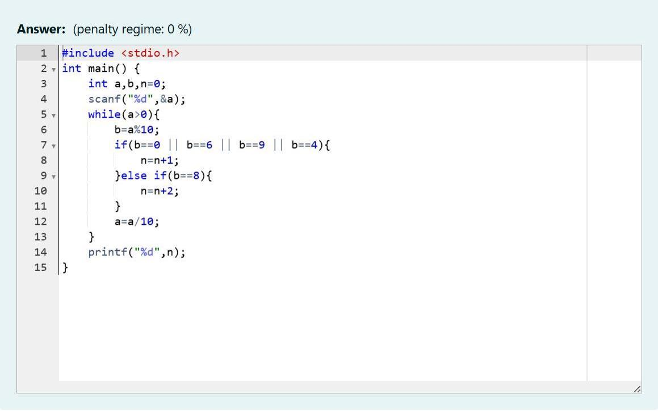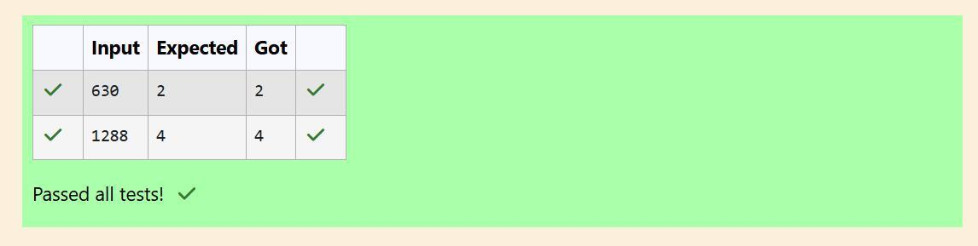

minimum is 3. Likewise, denominaons could also be {$1, $2, $4}. Hence answer is sll 3.

Manisha only {$1, $2, $3} coins are enough to purchase any item ranging from $1 to $5. Hence

For test case 2, N=5. According to Manish {$1, $2, $3, $4, $5} must be distributed. But as per

Likewise denominaons could also be {$1, $2, $3, $5}. Hence answer is sll 4.

Hence minimum is 4.

as per Manisha only {$1, $2, $3, $4} coins are enough to purchase any item ranging from $1 to $10.

Explanaon: For test case 1, N=10. According to Manish {$1, $2, $3,… $10} must be distributed. But

Sample Output 2: 3

Sample Input 2: 5

Sample Output 1: 4

Sample Input 1: 10

Refer the sample output for formang

1<=T<=100 1<=N<=5000

Constraints

Print a single line denong the minimum number of denominaons of coins required.

Output Format

Contains an integer N denong the maximum price of the item present on Philaland.

Input Format

max price in Philaland.

Your task is to help Manisha come up with a minimum number of denominaons for any arbitrary

impressed with both of them.

According to him any item can be purchased one me ranging from $1 to $5. Everyone was

could actually minimize the number of coins required and gave following distribuon {$1, $2, $3}.

purchase any item ranging from $1 ll $5. Now Manisha, being a keen observer suggested that we

Let’s suppose the maximum price of an item is 5$ then we can make coins of {$1, $2, $3, $4, $5}to

easily. He added the following example to prove his point.

starng from $1 ll the maximum price of the item present on Island, then we can purchase any item

coins with dierent values. Manish has come up with a soluon that if we make coins category

people were given a task to make a purchase of items at the Island easier by distribung various

Q3) The problem solvers have found a new Island for coding and named it as Philaland. These smart

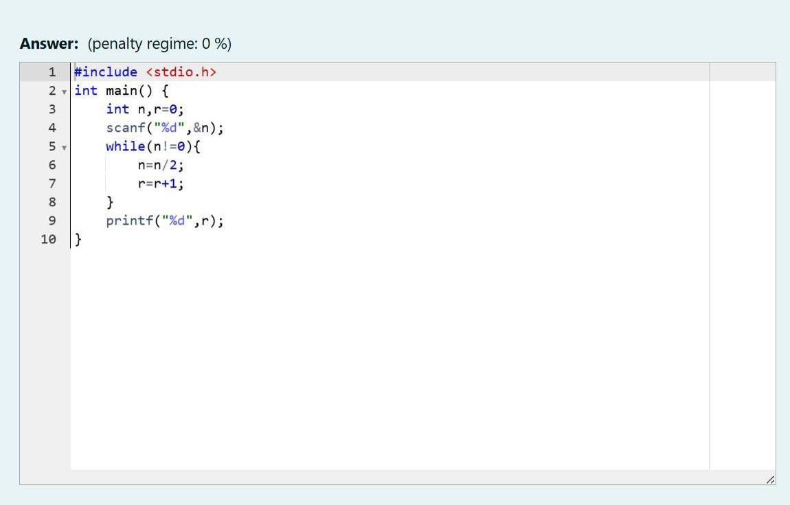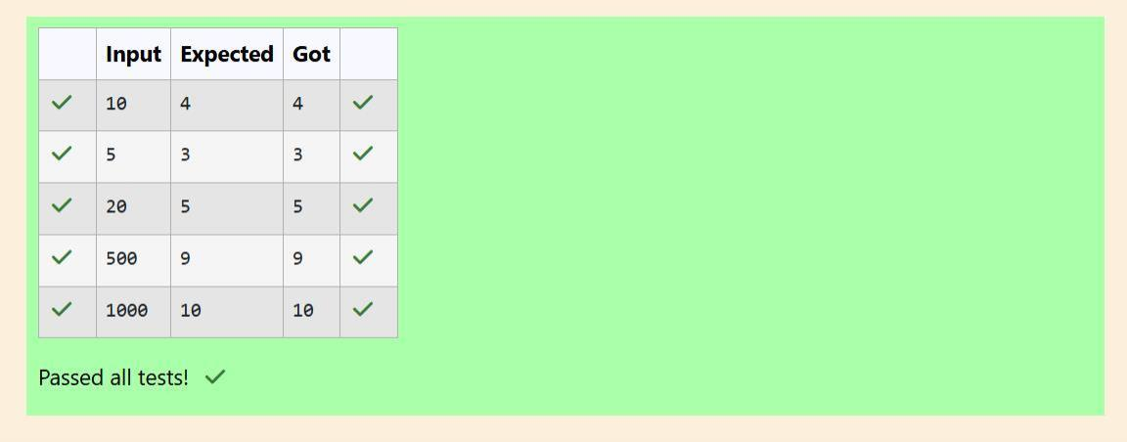

The numbers meeng the criteria are 5, 15, 25, 35, 45

Explanaon:

5

Output:

5 10 15 20 25 30 35 40 45 50

Input:

Input / Output 1:

Example

Output Format: The count of numbers where the numbers are odd numbers.

The value of the numbers can be from -99999999 to 99999999

Boundary Condions: 3 <= N <= 50

Input Format: The rst line will contain the N numbers separated by one space.

must idenfy the count of numbers where the number is odd number.

Q4) A set of N numbers (separated by one space) is passed as input to the program. The program

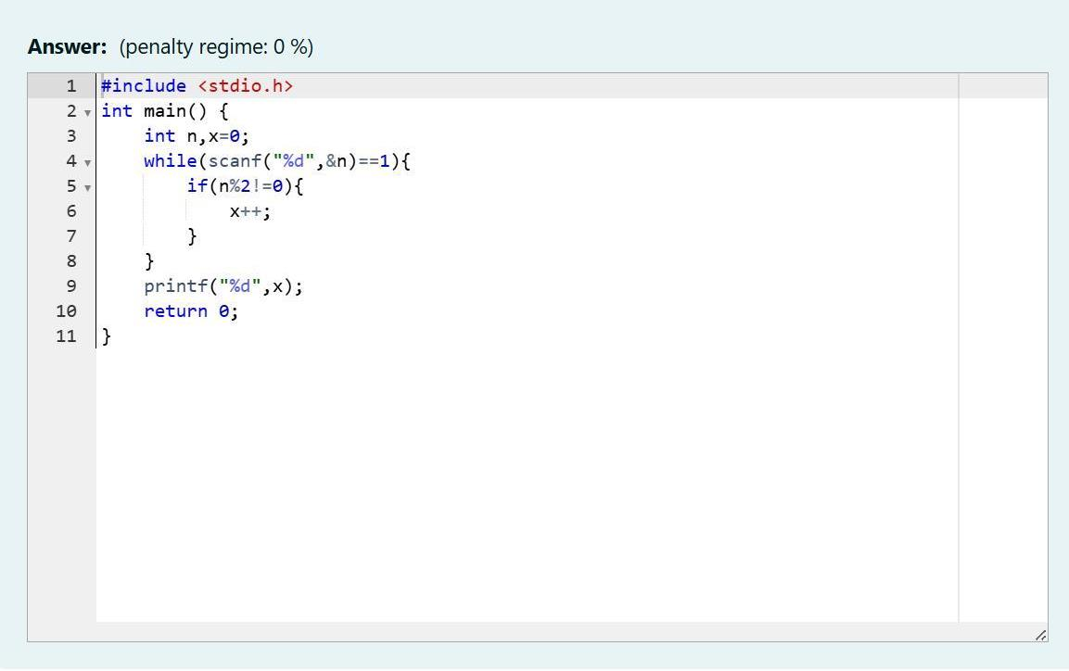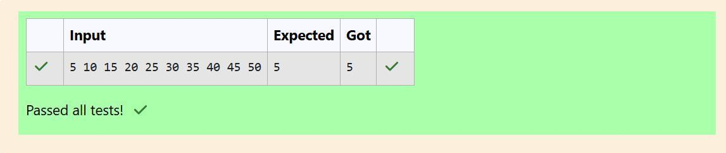

Explanaon: We get 68 aer rotang 89, 86 is a valid number and 86!=89.

Output: true

Input: 89

Example 2: 89 -> 68

Explanaon: We get 9 aer rotang 6, 9 is a valid number and 9!=6.

Output: true

Input: 6

6 -> 9

Example 1:

each digit valid.

A confusing number is a number that when rotated 180 degrees becomes a dierent number with

become invalid.

degrees, they become 0, 1, 9, 8, 6 respecvely. When 2, 3, 4, 5 and 7 are rotated 180 degrees, they

condion: We can rotate digits by 180 degrees to form new digits. When 0, 1, 6, 8, 9 are rotated 180

Q5) Given a number N, return true if and only if it is a confusing number, which sases the following

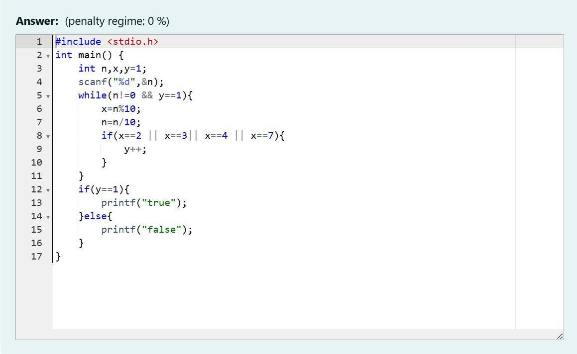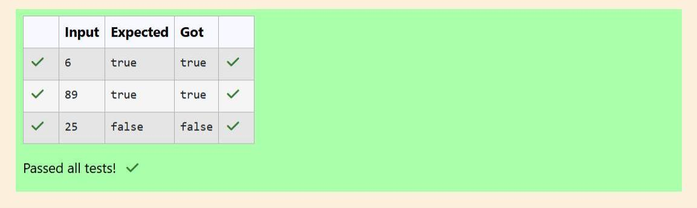

observe that this is the max total, and having avoided having exactly k = 2 macronutrients.

Explanaon - The following sequence of n = 2 food items: 1. 2. Item 1 has 1 macronutrients. 1 + 2 = 3;

0 43 3

Sample Output

0 2 2

Sample Input

The second line contains an integer, k, that denotes the unhealthy number.

The rst line contains an integer, n, that denotes the number of food items.

Input Format For Custom Tesng

1 ≤ n ≤ 2 × 109 1 ≤ k ≤ 4 × 1015

Constraints

k: an integer that denotes the unhealthy number

n: an integer that denotes the number of food items

It has the following:

(109 + 7).

It must return an integer that represents the maximum total of macronutrients, modulo 1000000007

Complete the code in the editor below.

Since 2 + 3 + 4 = 9, allows for maximum number of macronutrients, 9 is the right answer

1 + 2 + 4 = 7

1 + 3 + 4 = 8

2 + 3 + 4 = 9

needs to be skipped. Thus, the best combinaon is from among:

choosing items 1, 2, 3-> the sum is 6, which matches the 'unhealthy' sum. Hence, one of the three

Given 4 food items (hence value: 1,2,3 and 4), and the unhealthy sum being 6 macronutrients, on

Here's an illustraon:

without the sum matching the given 'unhealthy' number.

order of their value. Compute the highest total of macronutrients that can be prescribed to a paent,

(an 'unhealthy' number), and this sum is known. The nutrionist chooses food items in the increasing

macronutrients. However, the nutrionist must avoid prescribing a parcular sum of macronutrients

The nutrionist has to recommend the best combinaon to paents, i.e. maximum total of

and incremenng in this fashion.

example, food item with value 1 has 1 macronutrient, food item with value 2 has 2 macronutrients,

value associated with them. An item's value is the same as the number of macronutrients it has. For

single line, will have a value beginning from 1 and increasing by 1 for each, unl all items have a

Q6) A nutrionist is labeling all the best power foods in the market. Every food item arranged in a

